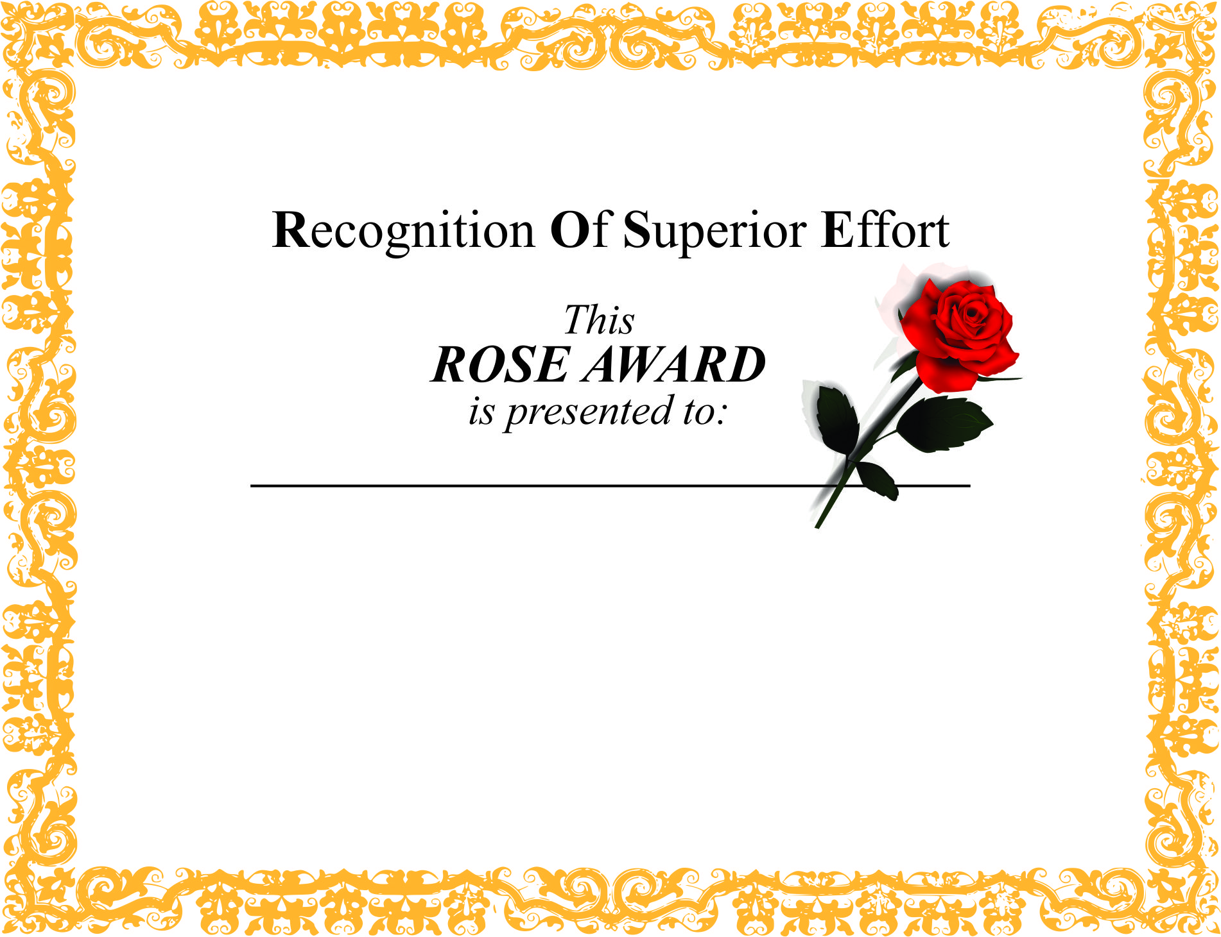

Insert School or District Name Here

Presented by insert name or group here

*In appreciation for the following effort to promote  
high levels of collaboration, instruction, learning, and leading* **Insert accomplishment to be recognized**

Insert name here

